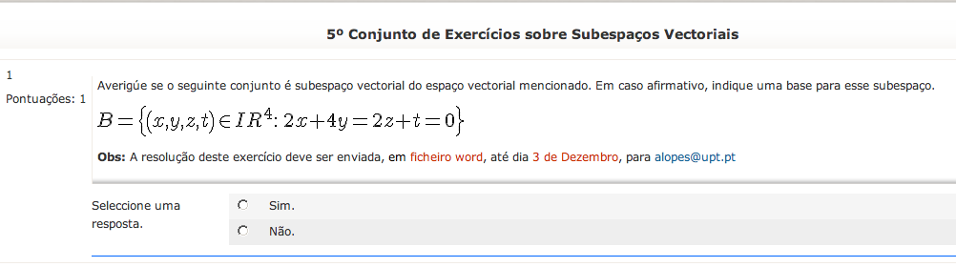

-Sim
-Não

- B 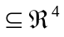 ✓
- 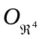=(0,0,0,0) 
- B={x,y,z,t) 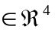: 2x+4y=2y+t=0}
={(-2y,y,z,-2z) : y, z }
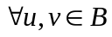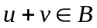
u→ u=(-2y,y,z,-2z)
→ v=(-2y’,y’,z’,-2z’)
u+v= (-2y-2y’), y+y’, z+z’, (-2z-2z’)
= -2(y+y’),y+y’, z+z’, -2(z+z’)
iv) 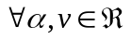 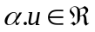
→ u= (-2y,y,z,-2z)
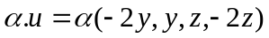
= (-2y,y,z,-2z)B

B={(-2y,y,z,-2z) : y,z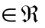}
={y(-2,1,0,0)+z(0,0,1,-2) : y,z}
B=<(-2,1,0,0), (0,0,1,-2)>

(-2,1,0,0) e (0,0,1,-2) gerem B

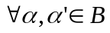

(-2,1,0,0)+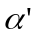(0,0,1,-2)=(0,0,0,0)
→==0\

|-2+0=0 |0=0
|-+0=0 |=0
|0+=0 |=0
|0-2=0 |0=0

l. i.
<(-2,1,0,0), (0,0,1,-2)> é uma base

